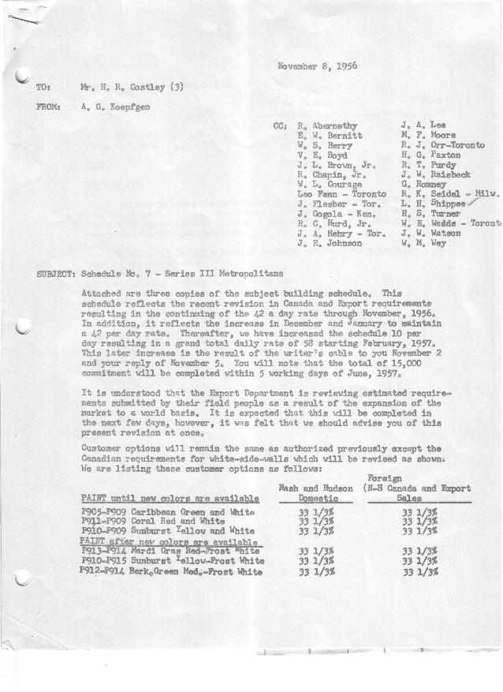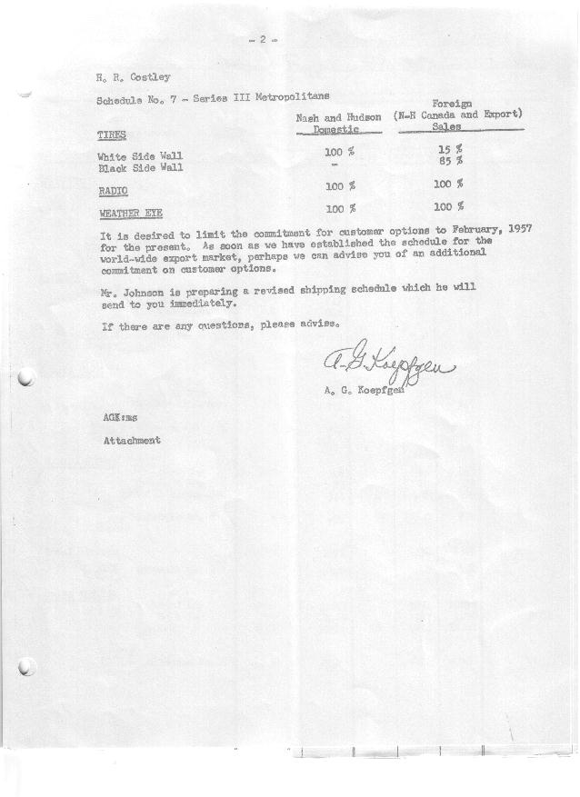

FORM PLAN 68 REV. 2-55-A.M.P Sheet 1 of 2 APPROVED E. W. Bernitt (signed) DATE 11-13/56

SCHEDULE NO. ______7 ___ DATE 11 /6 /56 MONTHLY BUILDING SCHEDULE APPROVED R. Abernethy (signed)_ DATE_ 11-9-56 ____
REVISION NO. _______ _______ DATE PRODUCT APPROVED ___ __DATE _ ____
SERIES III 1500 c.c. ENGINE
METROPOLITAN SERIES CARS – AUSTIN MTRS. CO., LTD, ENGLAND
DESCRIPTION | BUILT  ◻ACT EST  THRU  Sept. | FIRM BUILDING SCHEDULE  (FABRICATED MATERIAL RELEASE) |  |  |  |  |  |  |  |  |  |  |  |  |  |  | TENTATIVE SCHEDULE  (RAW MATERIAL RELEASED) |  |  | GRAND  TOTAL
DESCRIPTION | BUILT  ◻ACT EST  THRU  Sept. | MONTH Oct.  DAYS 23 |  |  | MONTH Nov.  DAYS 22 |  |  | MONTH Dec.  DAYS 18 |  |  | MONTH Jan.  DAYS 22 |  |  | MONTH Feb.  DAYS 20 |  |  | MONTH March  DAYS 21 |  |  | GRAND  TOTAL
DESCRIPTION | BUILT  ◻ACT EST  THRU  Sept. | DAILY | MONTH | CUM’L  TOTAL | DAILY | MONTH | CUM’L  TOTAL | DAILY | MONTH | CUM’L  TOTAL | DAILY | MONTH | CUM’L  TOTAL | DAILY | MONTH | CUM’L  TOTAL | DAILY | MONTH | CUM’L TOTAL | GRAND  TOTAL
DOMESTIC:
Hard-Top | 4755 |  | 544 | 5299 |  | 762 | 6061 |  | 595 | 6656 |  | 753 | 7409 |  | 714 | 8123 |  | 753 | 8876
Soft-Top | 541 |  | 116 | 657 |  | 60 | 717 |  | 78 | 795 |  | 82 | 877 |  | 130 | 1007 |  | 133 | 1140
Total U.S. | 5296 |  | 660 | 5956 |  | 822 | 6778 |  | 673 | 7451 |  | 835 | 8286 |  | 844 | 9130 |  | 886 | 10016
Over/(Under) Sched. No.6 | 0 |  |  | 0 |  | 60 | 60 |  | 71 | 131 |  | 79 | 210 |  | 204 | 414 |  | 214 | 628
FOREIGN:
EXPORT Hard-Top | 424 |  | 23 | 447 |  | 49 | 496 |  | 50 | 546 |  | 31 | 577 |  | 54 | 631 |  | 53 | 684
Soft-Top | 210 |  | 0 | 210 |  | 0 | 210 |  | 0 | 210 |  | 0 | 210 |  | 7 | 217 |  | 11 | 228
Total Export | 634 |  | 23 | 657 |  | 49 | 706 |  | 50 | 756 |  | 31 | 787 |  | 61 | 848 |  | 64 | 912
Over/(Under) Sched. No.6 | 0 |  | (70) | (70) |  | 20 | (50) |  | 19 | (31) |  | 31 | 0 |  | 0 | 0 |  | 0 | 0
CANADA NASH Hard-Top | 310 |  | 195 | 505 |  | 32 | 537 |  | 28 | 565 |  | 25 | 590 |  | 149 | 739 |  | 130 | 869
Soft-Top | 15 |  | 0 | 15 |  | 0 | 15 |  | 0 | 15 |  | 15 | 30 |  | 6 | 36 |  | 33 | 69
Total Nash-Canada | 325 |  | 195 | 520 |  | 32 | 552 |  | 28 | 580 |  | 40 | 620 |  | 155 | 775 |  | 163 | 938
Over/(Under) Sched. No.6 | 0 |  | 50 | 50 |  | 15 | 65 |  | 0 | 65 |  | 0 | 65 |  | 0 | 65 |  | 0 | 65
CANADA HUDSON Hard Top | 129 |  | 88 | 217 |  | 21 | 238 |  | 5 | 243 |  | 15 | 258 |  | 90 | 348 |  | 95 | 443
Soft Top | 10 |  | 0 | 10 |  | 0 | 10 |  | 0 | 10 |  | 3 | 13 |  | 10 | 23 |  | 10 | 33
Total Hudson Canada | 139 |  | 88 | 227 |  | 21 | 248 |  | 5 | 253 |  | 18 | 271 |  | 100 | 371 |  | 105 | 476
Over/(Under) Sched. No.6 | 0 |  | 20 | 20 |  | 15 | 35 |  | 0 | 35 |  | 0 | 35 |  | 0 | 35 |  | 0 | 35
TOTAL FOREIGN | 1098 |  | 306 | 1404 |  | 102 | 1506 |  | 83 | 1589 |  | 89 | 1678 |  | 316 | 1994 |  | 332 | 2326
Over/(Under) Sched. No.6 | 0 |  | 0 | 0 |  | 50 | 50 |  | 19 | 69 |  | 31 | 100 |  | 0 | 100 |  | 0 | 100
GRAND TOTALS
Hard-Top | 5618 |  | 850 | 6468 |  | 864 | 7332 |  | 678 | 8010 |  | 824 | 8834 |  | 1007 | 9841 |  | 1031 | 10872
Soft-Top | 776 |  | 116 | 892 |  | 60 | 952 |  | 78 | 1030 |  | 100 | 1130 |  | 153 | 1283 |  | 187 | 1470
Total | 6394 |  | 966 | 7360 | 42 | 924 | 8284 | 42 | 756 | 9040 | 42 | 924 | 9964 | 58 | 1160 | 11124 | 58 | 1218 | 12342
Over/(Under) Sched. No.6 | 0 |  |  | 0 |  | 110 | 110 |  | 90 | 200 |  | 110 | 310 |  | 204 | 514 |  | 214 | 728

FORM PLAN 68 REV. 2-55-A.M.P Sheet 2 of 2 APPROVED E. W. Bernitt (signed) DATE 11-13/56

SCHEDULE NO. ______7 ___ DATE 11 /6 /56 MONTHLY BUILDING SCHEDULE APPROVED R. Abernethy (signed)_ DATE_ 11-9-56 ____
REVISION NO. _______ _______ DATE PRODUCT APPROVED ___ __DATE _ ____
SERIES III 1500 c.c. ENGINE
METROPOLITAN SERIES CARS – AUSTIN MTRS. CO., LTD, ENGLAND
DESCRIPTION | BUILT  ◻ACT EST  THRU | FIRM BUILDING SCHEDULE  (FABRICATED MATERIAL RELEASE) |  |  |  |  |  |  |  |  |  |  |  |  |  |  | TENTATIVE SCHEDULE  (RAW MATERIAL RELEASED) |  |  | GRAND  TOTAL
DESCRIPTION | BUILT  ◻ACT EST  THRU | MONTH April  DAYS 20 |  |  | MONTH May  DAYS 21 |  |  | MONTH June  DAYS 5 |  |  | MONTH  DAYS |  |  | MONTH  DAYS |  |  | MONTH  DAYS |  |  | GRAND  TOTAL
DESCRIPTION | BUILT  ◻ACT EST  THRU | DAILY | MONTH | CUM’L  TOTAL | DAILY | MONTH | CUM’L  TOTAL | DAILY | MONTH | CUM’L  TOTAL | DAILY | MONTH | CUM’L  TOTAL | DAILY | MONTH | CUM’L  TOTAL | DAILY | MONTH | CUM’L TOTAL | GRAND  TOTAL
DOMESTIC:
Hard-Top |  |  | 714 | 9590 |  | 813 | 10403 |  | 239 | 10642
Soft-Top |  |  | 130 | 1270 |  | 73 | 1343 |  | 0 | 1343
Total U.S. |  |  | 844 | 10860 |  | 886 | 11746 |  | 239 | 11985
Over/(Under) Sched. No.6 |  |  | 204 | 832 |  | 214 | 1046 |  | (401) | 645
FOREIGN:
EXPORT Hard-Top |  |  | 50 | 734 |  | 56 | 790 |  | 11 | 801
Soft-Top |  |  | 11 | 239 |  | 8 | 247 |  | 2 | 249
Total Export |  |  | 61 | 973 |  | 64 | 1037 |  | 13 | 1050
Over/(Under) Sched. No.6 |  |  | 0 | 0 |  | 0 | 0 |  | (37) | (37)
CANADA NASH Hard-Top |  |  | 141 | 1010 |  | 154 | 1164 |  | 14 | 1178
Soft-Top |  |  | 14 | 83 |  | 10 | 93 |  | 0 | 93
Total Nash-Canada |  |  | 155 | 1093 |  | 164 | 1257 |  | 14 | 1271
Over/(Under) Sched. No.6 |  |  | 0 | 65 |  | 0 | 65 |  | (38) | 27
CANADA HUDSON Hard Top |  |  | 95 | 538 |  | 102 | 640 |  | 14 | 654
Soft Top |  |  | 5 | 38 |  | 2 | 40 |  | 0 | 40
Total Hudson Canada |  |  | 100 | 576 |  | 104 | 680 |  | 14 | 694
Over/(Under) Sched. No.6 |  |  | 0 | 35 |  | 0 | 35 |  | (45) | (10)
TOTAL FOREIGN |  |  | 316 | 2642 |  | 332 | 2974 |  | 41 | 3015
Over/(Under) Sched. No.6 |  |  | 0 | 100 |  | 0 | 100 |  | (120) | (20)
GRAND TOTALS
Hard-Top |  |  | 1000 | 11872 |  | 1125 | 12997 |  | 278 | 13275
Soft-Top |  |  | 160 | 1630 |  | 93 | 1723 |  | 2 | 1725
Total |  | 58 | 1160 | 13502 | 58 | 1218 | 14720 | 58 | 280 | 15000
Over/(Under) Sched. No.6 |  |  | 204 | 932 |  | 214 | 1146 |  | (521) | 625

